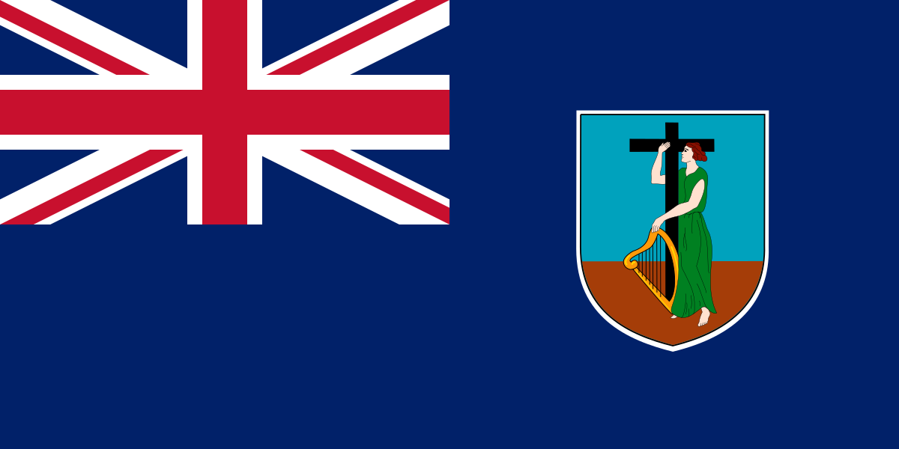
Government of Montserrat
APPLICATION FORM
COVID-Related Financial Support Heavily Impacted Sectors
Support for Businesses Affected by COVID-19
Eligible privately-owned businesses can apply for monthly Financial Support

Support is available to owners of companies and sole proprietorships for whom more than half of their annual income is earned in the following sectors:
• Tourist accommodation providers
• Tour operators, including both land- and marine-based
• Eateries/Restaurants
• Bars and clubs
• Other tourism-related businesses

Please state below the names and addresses of full-time employees on whom you have based your claim for Financial Support
Emp No. | Employee Name | Address | Gross Average Monthly Salary (six months)
 | Please add additional lines as necessary

